1. Open Repository Link: <https://github.com/ashreen26/Automation_Assignment/tree/master> in browser and Click on Code and Click on Download ZIP and Extract it.

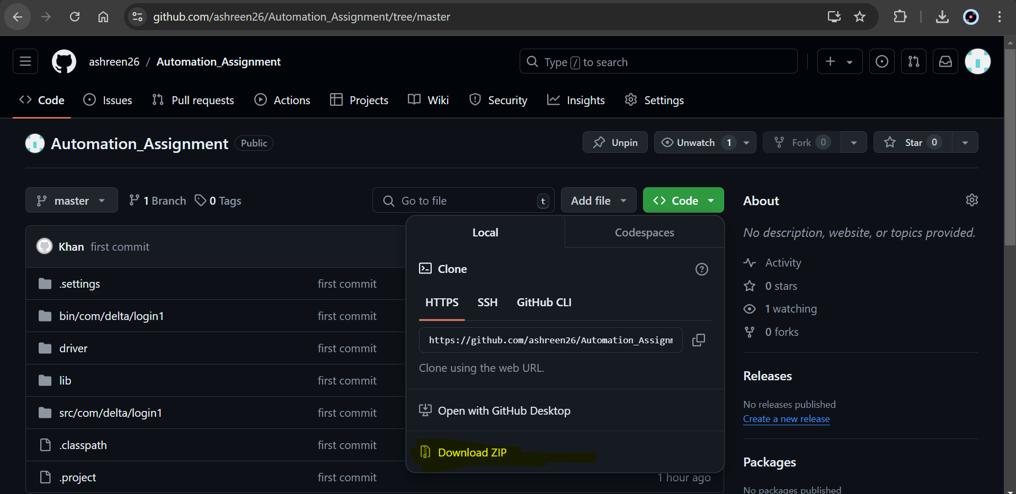

1. Open eclipse, Click on File and “Open Projects from File System”.

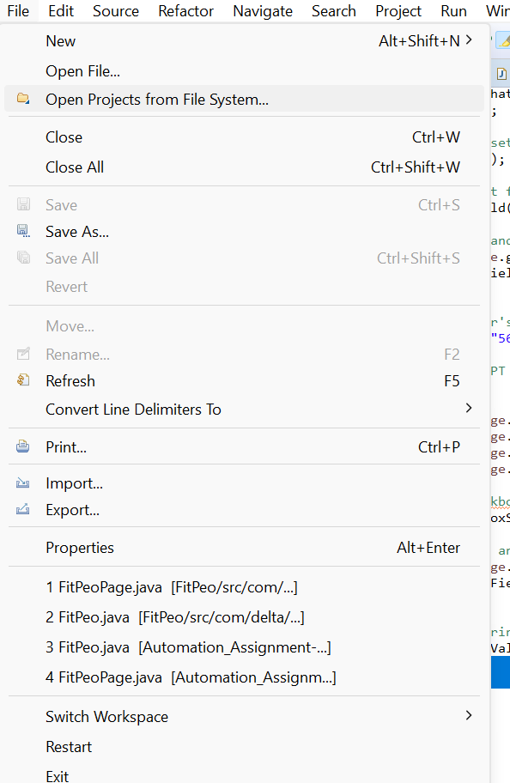

1. Click on Directory and browse the downloaded folder project path.

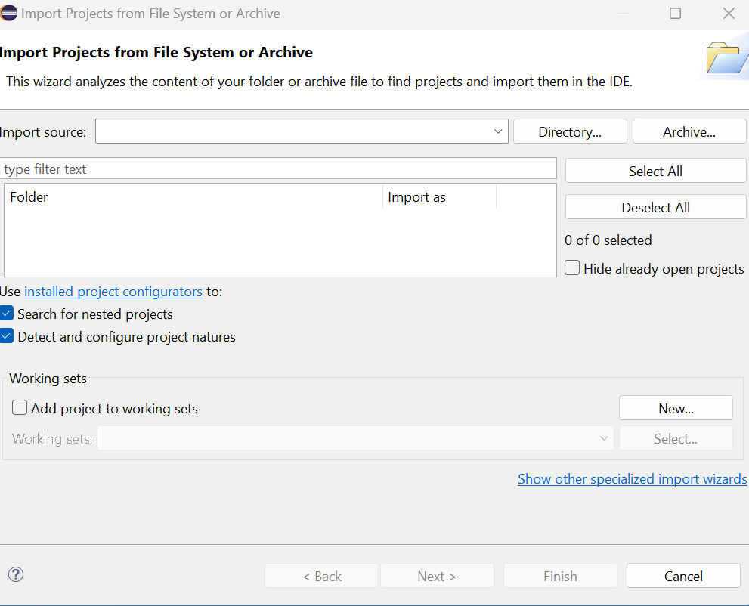

1. Click on Finish.

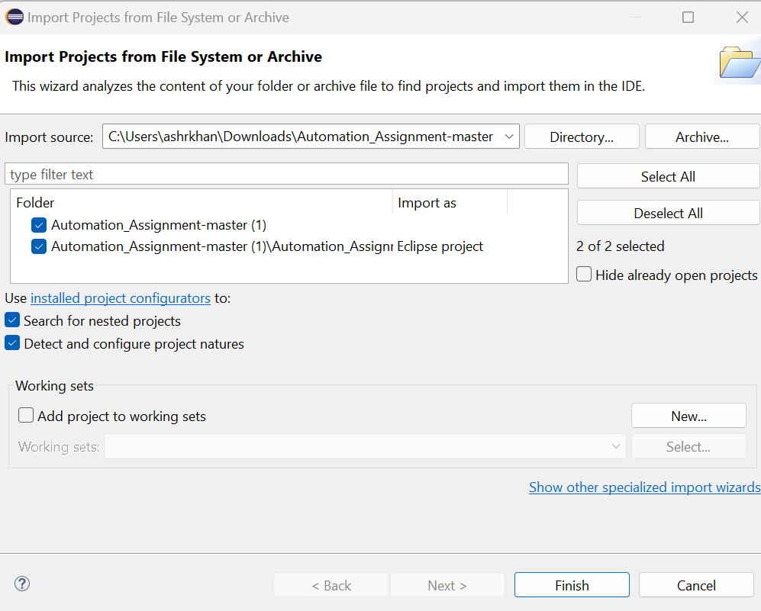

1. Open Automation_Assignemen- master > driver > chromdriver folder and copy the path.

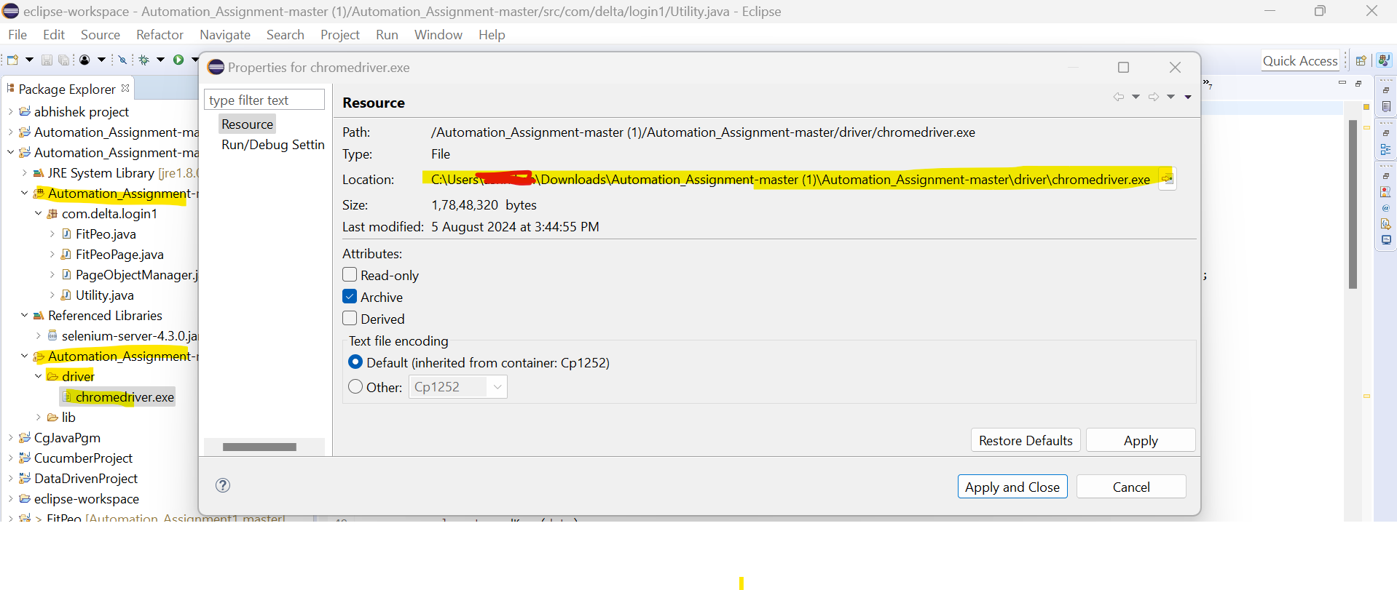

1. Paste the copied path in Utility File.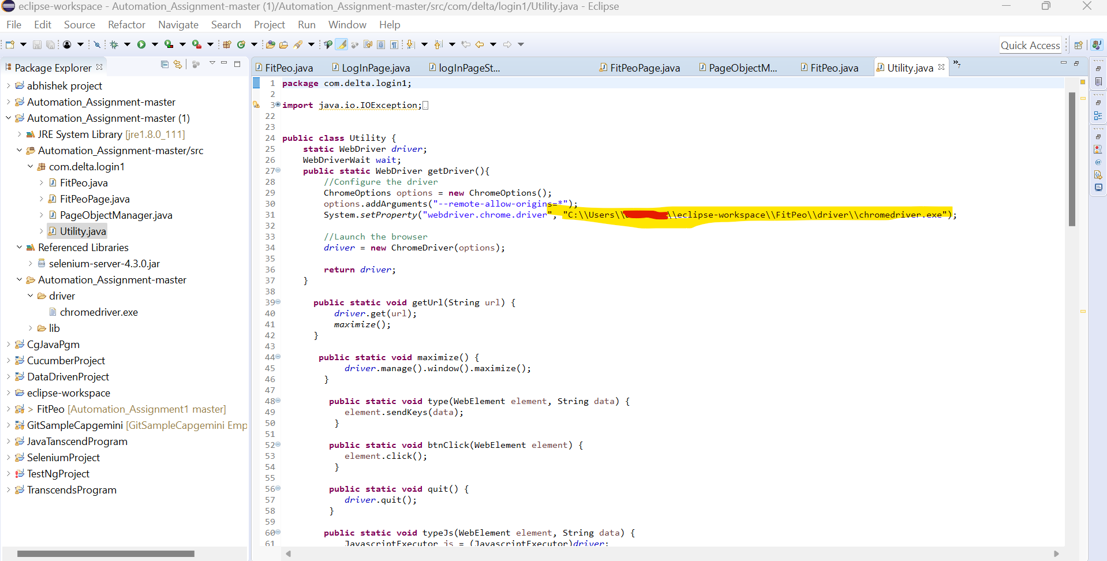
2. Run the “FitPeo.java” file.

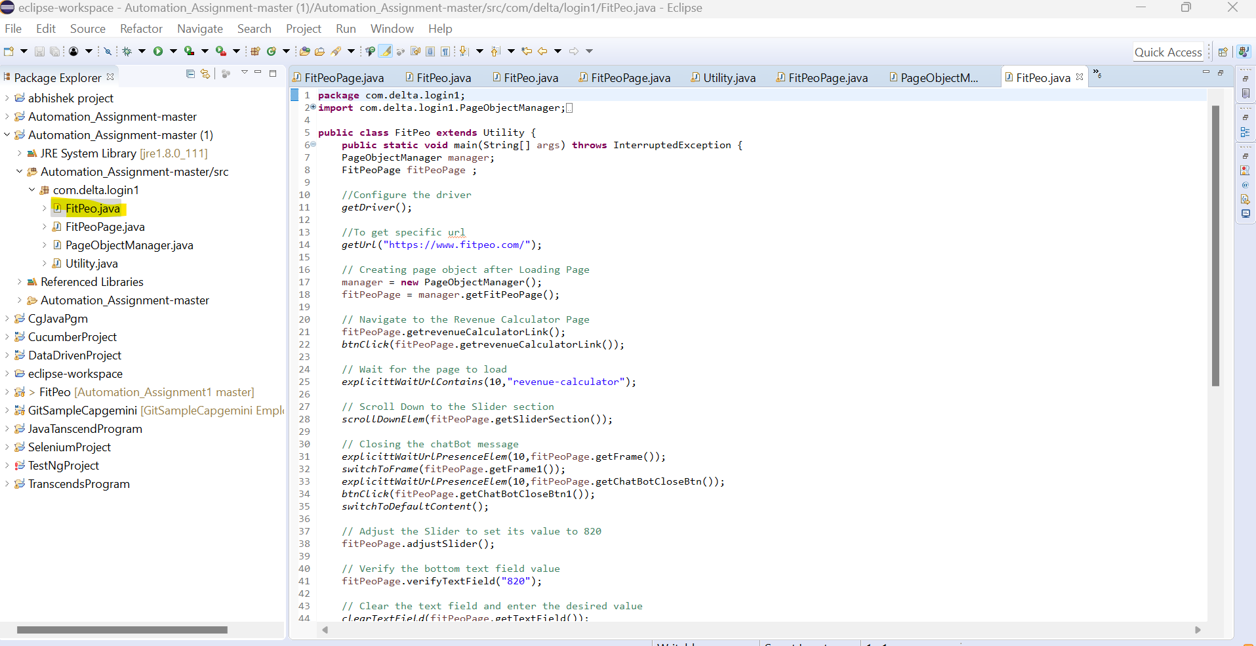

**Source code Overview.**

1. **Utility.java** will would typically contain reusable utility methods to support test scripts. These methods could include actions for interacting with web elements, handling waits, taking screenshots, managing test data, and more.
2. Using the Page Object Model (POM) design pattern, the **FitPeoPage.java** will contain all the locators and methods to interact with the elements of the FitPeo web page.
3. The **FitPeo.java** file will serve as the test script containing the code to run the test cases for the FitPeo application. This file will use the FitPeoPage class to interact with the web elements and perform the required actions.
4. A **PageObjectManager.java** is responsible for creating and managing the instances of all page objects in the application.